1. **Create a navigation bar similar to the below-mentioned image. The navigation bar must Contain 5 Navigation links that are properly placed within the navigation bar using the CSS box model. The navigation items must change their text color on hover.**

Solution:

<!DOCTYPE html>

<html lang="en">

<head>

<meta charset="UTF-8">

<meta name="viewport" content="width=device-width, initial-scale=1.0">

<title>Nevigtion Item </title>

</head>

<style>

.index{

background-color: #c3ebe7;

padding: 20px;

margin: auto;

}

a{

color: rgb(27, 86, 196);

margin-right: 15px;

margin-left: 20px;

}

a:hover{

color: rgb(2, 2, 70);

}

</style>

<body>

<nav class="index">

<a href="home">Home</a>

<a href="about">Abount Us</a>

<a href="contact">Contact</a>

<a href="Blog">Blog</a>

<a href="login">Login</a>

</nav>

</html>

Output:

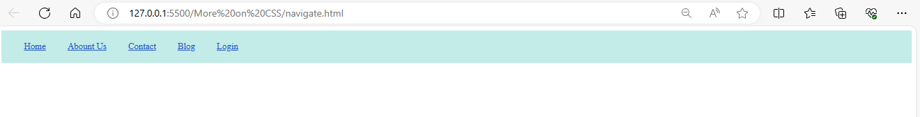

1. **Create a div cantered with an image and paragraph similar to the image mentioned below.**

Solution:

<!DOCTYPE html>

<html lang="en">

<head>

<meta charset="UTF-8">

<meta name="viewport" content="width=device-width, initial-scale=1.0">

<title>Image Paragraph</title>

<style>

.index{

margin: auto;

padding: 20px;

border-radius: 15px;

width: 300px;

background-color: antiquewhite;

}

</style>

</head>

<body>

<div class="index">

<img src="https://learn.pwskills.com/_next/image?url=https%3A%2F%2Fcdn.pwskills.com%2Fassets%2Fuploads%2Fthumbnails%2F64a514966977cc6e87e27504.png&w=1920&q=75" height="250px" width="300px" alt="Full Stack web development">

<p><b>Course Name:</b>PW Skill full stack Web development</p>

</div>

</body>

</html>

Output:

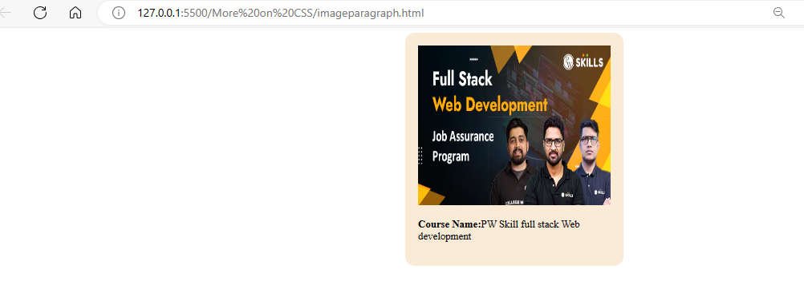

1. **Create a navigation bar similar to question 1. For each navigation item, use a different border style.**

Solution:

<head>

<meta charset="UTF-8" />

<meta http-equiv="X-UA-Compatible" content="IE=edge" />

<meta name="viewport" content="width=device-width, initial-scale=1.0" />

<title>Navigation Bar</title>

<style>

nav {

background-color: rgb(138, 243, 129);

padding: 20px;

}

a{

color: rgb(16, 52, 168);

margin-right: 25px;

margin-left: 20px;

}

a:hover {

color: red

}

.index1 {

border: 3px solid black;

padding: 5px;

}

.index2 {

border: 3px dotted black;

padding: 5px;

}

.index3 {

border: 3px double black;

padding: 5px;

}

.index4 {

border: 3px dashed black;

padding: 5px;

}

.index5 {

border: 3px groove black;

padding: 5px;

}

</style>

</head>

<body>

<nav>

<a href="#" class="index1">Home</a

><a href="#" class="index2">About Us</a

><a href="#" class="index3">Contact</a

><a href="#" class="index4">Blog</a

><a href="#" class="index5">Login</a>

</nav>

</body>

Output;



1. **Create a simple webpage with an image and make the image circular using border-radius.**

Solution:

<!DOCTYPE html>

<html lang="en">

<head>

<meta charset="UTF-8">

<meta name="viewport" content="width=device-width, initial-scale=1.0">

<title>Web page Image</title>

<style>

img{

background-color: yellowgreen;

width: 300px;

height: 280px;

border-radius: 40%;

}

</style>

</head>

<body>

<img src="/Media/1469437.jpg" alt="">

</html>

Output:

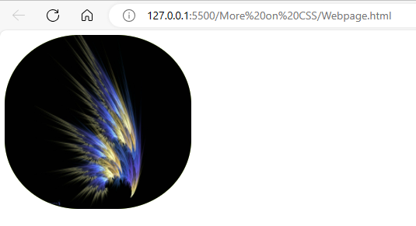

1. **Create a simple blog website about Google fonts. The webpage must have the heading with “Oswald” font align 'enter to the !age, below the heading have an image of Google fonts and a paragraph about Google fonts in font “Montserrat” paragraph font style should be “montserrat” font.**

Solution:

<!DOCTYPE html>

<html lang="en">

<head>

<meta charset="UTF-8">

<meta name="viewport" content="width=device-width, initial-scale=1.0">

<title>Google Font</title>

<style>

h1{

text-align: center;

background-color: aliceblue;

font-family: "Oswald" sans-serif;

}

img{

width: 300px;

height: 200px;

}

p{

font-family: "Montserrat", sans-serif;

}

</style>

</head>

<body>

<h1>Google Font</h1>

<img src="/Google Fonts.png" alt="Google fonts">

<p>Google Fonts makes it easy to bring personality and performance to your websites and products. Our robust catalog of open-source fonts and icons, makes it easy to integrate expressive type and icons seamlessly—no matter where you are in the world</p>

<p>Our font catalog places typography front and center, inviting users to explore, sort, and test fonts for use in more than 135 languages. We showcase individual type designers and foundries, giving you valuable information about the typographers and their process, as well as analytics on usage and demographics. Our series of thematic collections helps you discover new fonts that have been vetted and organized by our team of designers, engineers, and collaborators, and our default sort organizes fonts based on popularity, trends, and your geographic location. You can also create your own highly customized collections by filtering families, weights, and scripts, plus test color themes, and review sample copy. Collections can be shared, making it easy to collaborate on projects and ensure typography is optimized and streamlined throughout the design and engineering process. In 2021, we added icons to our Google Fonts catalog, expanding expressive capability for our users. Our first set was the Material icons—delightful, beautifully crafted symbols for common communication needs. Download them on desktop to use them in your digital products for Android, iOS, and web.</p>

</body>

</html>

Output:

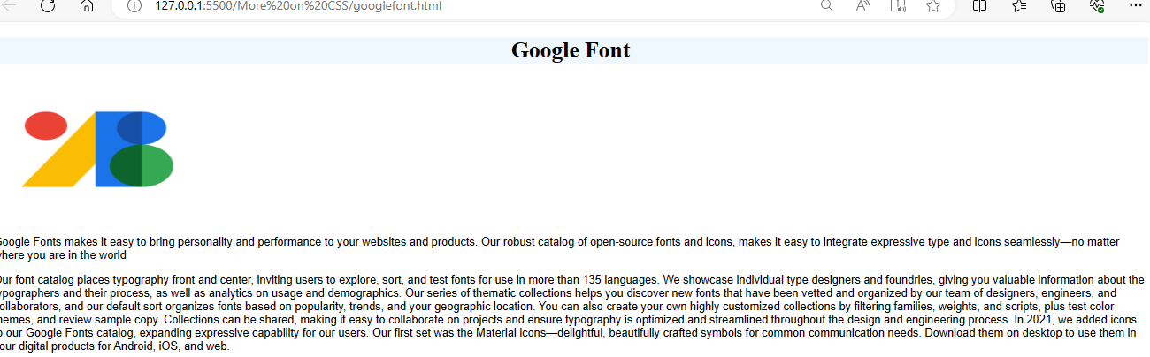

1. **Create a simple website as mentioned in the below image. You can get the assets by visiting https//pwskills.com/about-us.**

Solution:

<!DOCTYPE html>

<html lang="en">

<head>

<meta charset="UTF-8">

<meta name="viewport" content="width=device-width, initial-scale=1.0">

<title>About Pw skill</title>

<style>

h1{

text-align: center;

font-family: "poppins", sans-serif;

font-weight: bold;

font-size: 40px;

}

p{

font-family: "poppins", sans-serif;

padding: 10px 14px;

margin: 20px;

}

img{

margin-left: 40px;

margin-right: 20px;

}

</style>

</head>

<body>

<h1>About Us</h1>

<p>PW Skills' mission is to permeate through every student/professional's outlook towards jobs and change their attitude and perspective from "How Can I Do It?" to "Of Course I Can Do It". We aim to do this by providing exceptional up skilling courses at affordable rates, while being tech-forward so anyone, anywhere can access and improve their ability to be successful in life.</p>

<img src="https://pwskills.com/images/aboutUs/aboutUs.png" alt="About PWSkills">

</body>

</html>

Output:

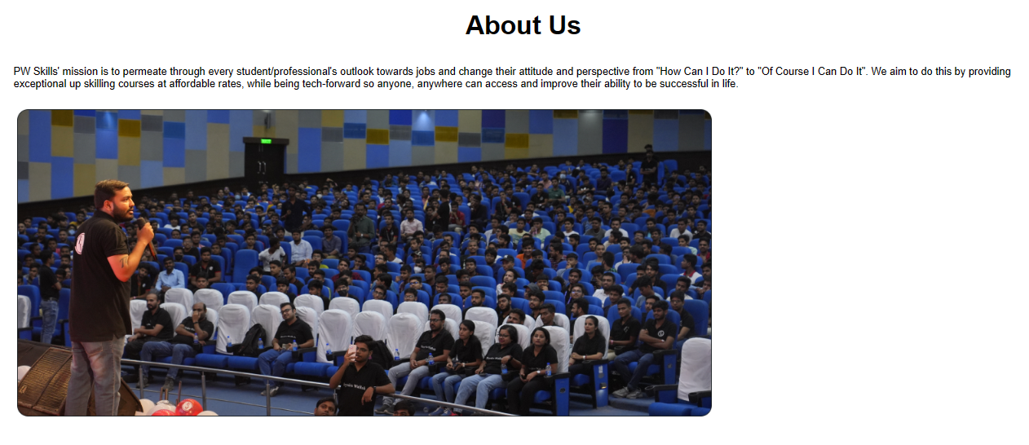

1. **Create simple webpage with a card similar to question number 2. The card must be semi-transparent as default and on hovering he card must be displayed clearly. Use CSS opacity achieve this output.**

Solution:

<!DOCTYPE html>

<html lang="en">

<head>

<meta charset="UTF-8">

<meta name="viewport" content="width=device-width, initial-scale=1.0">

<title>Image Paragraph</title>

<style>

.index{

margin: auto;

padding: 20px;

border-radius: 15px;

width: 300px;

background-color: antiquewhite;

opacity: 1;

}

.index:hover{

opacity: .5;

}

</style>

</head>

<body>

<div class="index">

<img src="https://learn.pwskills.com/_next/image?url=https%3A%2F%2Fcdn.pwskills.com%2Fassets%2Fuploads%2Fthumbnails%2F64a514966977cc6e87e27504.png&w=1920&q=75" height="250px" width="300px" alt="Full Stack web development">

<p><b>Course Name:</b>PW Skill full stack Web development</p>

</div>

</body>

</html>

1. **Create a simple list of items as mentioned in the below image.**

Solution:

<!DOCTYPE html>

<html lang="en">

<head>

<meta charset="UTF-8">

<meta name="viewport" content="width=device-width, initial-scale=1.0">

<title>Document</title>

<style>

li{

list-style-type: lower-roman;

}

</style>

</head>

<body>

<h1>Requirments</h1>

<ul>

<li>System with minimum i3 processer or better</li>

<li>At list 4GB of Ram</li>

<li>Working internet connection/li>

<li>Dedecation to learn</li>

</ul>

</body>

</html>

Output:

